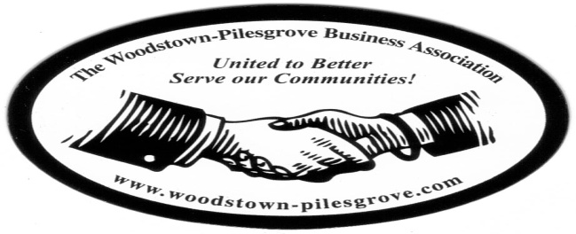

Woodstown-Pilesgrove Business Association
General Membership Meeting Agenda
Wednesday – September 9, 2015

Memorial Hospital of Salem County, Woodstown Medical Office
66 East Avenue, Woodstown

Mission Statement: To Promote and Support our Local Businesses through
Networking, Shared Success and Training Opportunities

Facilitated by: Kevin R. Gibala

Roll Call

Treasurer’s Report
- General Account:
Beg Balance_______________
Income___________________
Expenses________________
End Balance______________
- 4th of July Account: _____________

President’s Report
- Motion/ Approval of General Membership Minutes from July
- Update from June Officers and Trustees Meeting
- New Member Update
- Fall Festival - Sat, Sept 26th
- W-PBA Newsletter

Committee Reports:

Website Committee – Lori Petronglo

Ambassador Committee – Paul Horvath

Government Relations Committee – Joe Crevino

Activities/Programs – Hue Grant & Chris Williams
- October – Doug Painter, (Dave Zeck from Salem County One Stop)
- November – Chris Williams
- December – Anne Elder

Promotion, Marketing & Fundraising – Anne Elder

Today's Program: Memorial Hospital of Salem County, Ryan Jensen, CEO

Upcoming Dates, Events & Mixers to look for:
- Fall Festival - Sat, Sept 26th
- W-PBA Networking Event – October 4th
- The Pumpkin Show – October 9,10,11

Adjourn Meeting and Networking

Next General Membership Meeting - Wednesday, October 14, 2015
Friends Village

