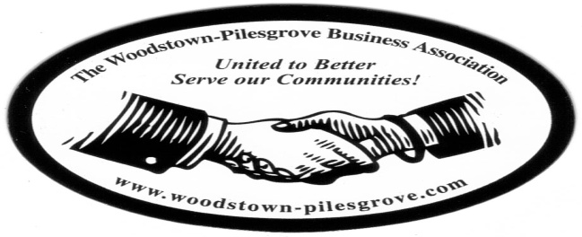

Woodstown-Pilesgrove Business Association
General Membership Meeting Minutes
March 11th, 2015
Creekside Inn – Dinner Meeting

Mission Statement: To Promote and Support our Local Businesses through
Networking, Shared Success and Training Opportunities
______________________________________________________________________________

This meeting did not follow our usual format because it was a Dinner Meeting for the installation of our new Officers and Trustees. Doug Painter, Chairman of the Activities Committee acted as the Master of Ceremony. He started by welcoming everyone followed by a roll call. Immediately following that he introduced Rev. David Hoeldtke to lead us in the invocation.

After dinner Pilesgrove Mayor Kevin Eachus swore in Peggy Scheule as our president for 2015-2016. He then followed by swearing in all officers and trustees.

President’s Report:

Peggy gave a heartfelt thank you to all the members of the WPBA who have worked tirelessly in supporting and promoting our organization. She made a special thank you to Charlie Bell for his work on revamping our website and encouraged everyone to go on line and check it out. She also thanked Paul Horvath for his work on the Ambassador’s Committee, Doug Painter for his efforts in securing a monthly speaker at every meeting. She also made mention that Doug will be stepping down as the Committee Chairperson as well as a trustee in order to free up his time for his new roll as County Freeholder…he will be missed, however, he will continue to be an active member of the organization. She thanked Joe Crevino for his efforts to keep us informed of any new local government issues that may affect our businesses as well as supplying us with chocolates from “Sweet Mary”, Linda Hodge for her 5 years of service as our treasurer, Chris Williams for taking on that roll of our treasurer and Lori Petronglo for her commitment to keep us all informed as to what is going on in the association through emails, and our website.

Peggy spoke about our accomplishments this past year. Some of those were:

- Our dues has remained at $125, and has been this amount since the association was revitalized in 2007
- The improvements made to our website, some of which are:
- New membership sign-up on line
- Posting of General Meeting Minutes
- Updated pictures of current events
- Bringing back business of the month to be featured monthly…
- Info on all upcoming events and meetings
- Directions to the next general meeting.
- Our first annual Golf Outing
- Our support of the July 4th Fireworks in 2014
- Our new brochures
- Our commitment to our “On The Road” general meetings.

Peggy also mentioned our Golf Outing planned for May 22nd thanks to the hard work of Anne Elder and the formation of the new July 4th Fireworks Committee being co-chaired by Anne and Keith Elder.

Vice President Report:

This year we had 2 new awards “New Business of the Year” and “Outstanding Business of the Year”. These awards were presented by Kevin Gibala and Peggy Schuele. The awards winners were as follows:

- New Business of the Year - Chris Williams CPA., Chris Williams accepted this award.
- Outstanding Business of the Year –Print, Signs and Designs - Aaron Crispin and Susan Jones (unfortunately neither Aaron nor Susan was present to receive their award in person due to circumstances beyond their control).

The meeting ended with a fun game of Network Bingo enjoyed by all.

