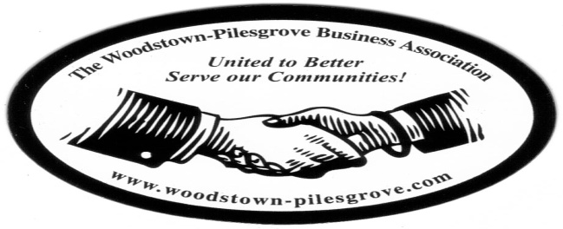

Woodstown-Pilesgrove Business Association
General Membership Meeting Minutes
Wednesday, June 10, 2015
Friends Village

Mission Statement: To Promote and Support our Local Businesses through
Networking, Shared Success and Training Opportunities

Facilitated By:

Peggy Scheule

Treasurer’s Report:

Beg Balance: 8742.00
Income: 875.00
Expenses: 100.00
End Balance: 9517.08
Golf Balance: 4825.45

John Gasparon motioned to accept the Treasurer’s Report, Karen Sparks seconded

President’s Report:

Peggy praised Anne Elder for her dedication and hard work on our 2nd Annual Golf Tournament; it was a huge success. The weather was beautiful and the atmosphere was festive; we raised $8400.00.

She reminded everyone who brought in food donations for the Disciple’s Food Pantry that she will see that the donations are delivered.

Our guest presenter today is the Future Business Leaders of America.

Also the recipient of the Paul Langley Scholarship, Jose Alcantar Pizano, a senior at Woodstown High School and a member of FBLA, was presented with the scholarship check by Peggy.

VP Report:

Kevin was not available for an update but Peggy asked us to keep in mind a business that we feel may be a good candidate for the Outstanding Business of the Year award; any nominations should be sent to Kevin.

Committee Reports:

Website Committee: Lori Petronglo – Kevin Gibala

The “go fund-me” link is now at the top right hand corner of our website. Lori encouraged everyone to share this on their Facebook pages and promote donating towards the July 4th Fireworks. We are still working on deciding on a new template for our website. Once we have decided on the template, we will be able to put a calendar on that will show events month-to-month, this will also allow us to add more pages as needed. There will be new pictures of the Golf Tournament up soon, as well as updates on the Fireworks.

Ambassador Committee: Paul Horvath

Paul thanked Aaron Crispin for bringing a guest, the owner of the Elmer Diner; he asked that we continue to talk to old and potentially new members about our association.

Government Committee: Joe Crevino

Joe was not available for an update

Activities/Programs: Hue Grant

Hue shared that our July presenter will be the Red Cross sponsored by Serv Pro.

Promotion/Marketing: Anne Elder

Golf Tournament:

Anne reported that the Golf Tournament was a huge success. There were 85 golfers and almost all stayed for the dinner. She said next year it will be held on May 20th. She thanked everyone for their help.

Fireworks:

The “go fund me” link is up Anne encouraged the members to promote it so other businesses will make donations. Anne also stated that although we made enough to pay for the fireworks this year, we need to have a surplus for next year so we aren’t under so much pressure for next year with regards to money.

Andy Ware was available to speak about the 5K Firecracker Run; the run has been approved by Woodstown, we have the services of a company that runs this sort of fund raisers for a living, they will be running the race.

Pre-registration for the race will be $20, it starts at 6:45, anyone who registers the day of the race will pay $25. Andy and Anne asked for volunteers to help with checking people in and for the water hand out on the race route. He said that we had 270 racers last year and that this promises to be a big money maker for our association. The race starts at the park.

Anne spoke about the Fireworks; with the help of the fire marshall we were able to get our firearms permit. She also stated that the only entrance for the fireworks will be on Grandview Dr., Marlton Rd will be closed. The fireworks will go off around dusk. She is in need of about 25 people to help with various jobs during the fireworks.

Presenter:

FBLA advisor, Cheryl Levitsky introduced two members who give a short talk about their experiences as members of the FBLA. Jessica, a freshman shared that she will be attending the national conference in Chicago this year, Jessica came in 3rd place in a state competition with her Desk Top Publishing presentation and Cole a senior talked about his involvement in the March of Dimes and fundraisers.

Topics for Discussion:

What do you as a business do for relaxation?

This discussion was met with many different ways we all take the time to unwind and relax after a stressful day at work.

Shout Outs:

Judy and Hue thanked Debbie Callahan for her help in giving them a room and support for an event they hosted.

Anne and Keith were thanked for all their work on the Golf Tournament and the Fireworks.

Aaron asked if anyone needs help in doing a mass mailing to contact him, he can show you how to do it with minimal cost. He is doing a seminar in September for the Salem County Chamber, if anyone would like to attend.

Tracy Priest motioned to adjourn and John Gasparon seconded.

Next General Membership Meeting will be on Wednesday, July 8, 2015
Friends Village, 7:30 Breakfast, 7:45 Meeting.

