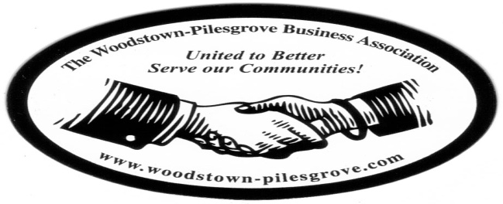

Woodstown-Pilesgrove Business Association
General Membership Meeting Minutes
Wednesday, September 9, 2015
The Memorial Hospital of Salem County
Woodstown Satellite Office

Mission Statement: To Promote and Support our Local Businesses through
Networking, Shared Success and Training Opportunities

Facilitated By:

Kevin Gibala

Treasurer’s Report:

Beg Balance: 8324.21
Income: 11338.14
Expenses: 10338.14
End Balance: 9047.35
Golf Balance: 9572.45
July 4th/Golf Tournament Seed 7297.94

Karen Sparks motioned to accept the Treasurer’s Report, Kevin Gibala seconded

President’s Report:

Peggy was not available for this meeting so Kevin Gibala, our Vice President, conducted our meeting. Kevin thanked Ryan Jensen for having us and for the breakfast he made available.

We discussed the Fall Festival that will be held the end of September, the discussion involved whether or not we will have a person manning the table or just a sign reminding the residents that we are the”Proud Supporters of the July 4th Fireworks” and thanking the sponsors of the Golf Tournament.

Debbie Callahan announced that she is leaving her position at Friends Village to take a new position as VP of Marketing and Development with Westminster-Cantebury Retirement Community in Lynchburg, VA, she invited everyone to a farewell gathering for her at Friends Village in the Fenwick Lobby, on Friday, Oct 2.

VP Report:

Kevin was acting president today.

Committee Reports:

Website Committee: Lori Petronglo – Kevin Gibala

Lori went over the changes they are planning for the new website. She asked that any members of the Officers and Trustees to please try and make themselves available for pictures at our next OT meeting in October. She also asked for a short bio for each member; each member’s bio will be displayed under their name. She also talked about the calendar that will be on the website, she mentioned that they want to add local happenings in the community on the calendar. She asked that if anyone knew of anything that they thought should be put on the calendar to contact herself or Charlie Bell.

Ambassador Committee: Paul Horvath

Paul was not available for comment

Government Committee: Joe Crevino

Joe shared that Pilesgrove just purchased a new ladder firetruck for Pilesgrove for $837,000. He also talked about the on-going problem with the number of abandoned houses in Pilesgrove.

Activities/Programs: Hue Grant

Doug Painter will have Dave Zack from “One Stop” as the guest speaker for October.
November’s speaker will be sponsored by Chris Williams and December’s will be Anne Elder.

Promotion/Marketing: Anne Elder

The newsletter was discussed. Karen is going to get together with Aaron to go over what they did last year and what they need to do to get this one printed and distributed.

Presenter:

Ryan Jensen of the Memorial Hospital Of Salem County talked about the changes he has been working on to make the hospital more appealing to the public. He focused on their emergency room response time for patients who come in, pledging a 30 minute or less response time. He also talked about the types of specialty practices/doctors they have added to their staff and what they offer. It was very informative.

Topics for Discussion:

Shout Outs:

Next General Membership Meeting will be on Wednesday,
October 7, 2015 –Friends Village, 7:45

