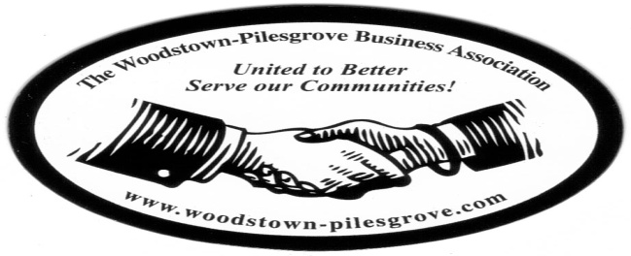

Woodstown-Pilesgrove Business Association
Officers & Trustees Meeting Minutes
Thursday, July 2,, 2015
Warner & Company

Mission Statement: To Promote and Support our Local Businesses through Networking, Shared Success and Training Opportunities.

Facilitated By:

Peggy Scheule

Treasures Report:

Beg Balance:
Income:
Expenses:
End Balance:
Golf Balance

Due to insufficient number of members in attendance to qualify as a quorum, this meeting was held as an “informal meeting.”

President’s Report:

We discussed the September “On The Road” General Meeting; the Memorial Hospital of Salem County will sponsor our next meeting at their Woodstown location hosted by their CEO Ryan Jensen.

The Salem County Chamber has offered our members to use their booth to promote their business as well as the W-PBA. John Gasparon offered to bring our brochures to their booth.

ServPro Salem, is in charge of having a presenter for the July meeting; they have invited the American Red Cross to be our speaker.

Vice President’s Report:

Kevin was not available for comment

Website Committee- Lori A Petronglo, Kevin Gibala

Lori talked about the template for our new website look. She announced that Charlie has finished updating the email list through google, that he is working on the putting the Platinum sponsors for the Golf Tournament up and he is working on the scroll across the top.

In this discussion Anne asked if we might be able to change the July meeting to the week before because she will be away on vacation; Lori is looking into this.

Ambassador Committee- Paul Horvath

Paul was not available for comment

Government Relations Committee – Joe Crevino

Joe was not available for an update.

Activities/Programs – Hue Grant

Hue was not available for comment however, Anne Elder showed up a copy of what the new banner for the parade will look like.

Promotion/Marketing –Anne Elder

Anne discussed the last minute things she was getting together for the fireworks and the 5K Run Parking issues were discussed as well as the parking signs asking for a $5 donation, the volunteers who are helping with the 5K Run and Fireworks, T-Shirts for the race and signs that would display the names of the Silver Sponsors from the Golf Tournament.

Anne said the parade starts at 10 AM and that anyone who is walking in the parade should be there by 9. Tracy will supply the candy for the candy toss during the parade.

Pyrotech will be at the parade sight by 12 noon to begin setting up and the Fireworks will start at dusk.

Table Topic:

The table topic for our next General Meeting will be, ”Can I ask your opinion on this?

Next Officers’ and Trustees’ Meeting, Thursday, September 3, 2015
Warner & Company, 8:15

