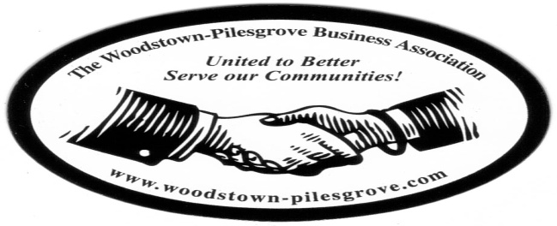

Woodstown-Pilesgrove Business Association
General Membership Meeting Minutes
Wednesday, May 13, 2015
Friends Village

Mission Statement: To Promote and Support our Local Businesses through
Networking, Shared Success and Training Opportunities

Facilitated By:

Peggy Scheule

Treasurer’s Report:

Beg Balance: 8477.25
Income: 6914.00
Expenses: 2896.00
End Balance: 8742.00
Golf Balance: 4783.00

Joe Crevino motioned to accept the Treasurer’s Report, Kevin Gabala seconded

President’s Report:

Paul Horvath motioned to accept the minutes from April’s General Meeting and Karen Sparks seconded.

Peggy talked about the Paul Langley Scholarship, she told the group that they had decided on the recipient and that he along with the FBLA would be at our next meeting. It will be at this meeting that the recipient will be announced and awarded the scholarship. The FBLA will be our presenter at this meeting telling us about the organization. Peggy also mentioned that we are talking about adding that any applicant must be a member of the FBLA, to the criteria that an applicant must be able to fulfill in order to be a viable candidate for the scholarship.

The opening of Miller’s Market was announced; we were encouraged to support this new business.

With regards to the July 4th Parade; Peggy secured a permit application and strongly suggested that since the WPBA is sponsoring the fireworks, we should be the Grand Marshall of the parade.

VP Report:

With regards to the Outstanding Business of the Year award; Kevin asked that we email him if a business has done something notable that may qualify them to be considered for the award.

Committee Reports:

Ambassador Committee: Paul Horvath

Paul asked that we continue to talk to old and potentially new members about our association. He also talked about visiting businesses with Anne, Peggy and Linda last week.

Government Committee: Joe Crevino

Joe discussed the reconstruction of Rts. 45 and 40 that is slated to begin sometime in 2016. He also announced that Pilesgrove now has a new firetruck tanker.

There was also some discussion about Affordable Housing and abandoned houses in the area.

Peggy asked Doug Painter (who is the liaison between us and Salem Chamber of Commerce, as well as our county freeholder), if he had any updates. Doug stated that they are reaching out to businesses throughout the year to inform them about the tax advantages of hiring from unemployment.

He also spoke about the advantage we have with close access to major highways which is a great way to entice new businesses to open in Woodstown-Pilesgrove/Salem County. Doug shared with the group that a new business that just relocated to our area from Delaware.

Activities/Programs: Hue Grant

Hue announced that he is resending his original email with the listing of presenters for the year as a reminder. He is also working on a banner for our association to be used in the parade.

Promotion/Marketing: Anne Elder

Golf Tournament:

Anne updated us on her progress and exactly what she is still in need of; as of this meeting she had 29 hole sponsors and 88 golfers. She feels the number of golfers could still grow before the actual day of the event. She asked for more donations of gift cards, and volunteers to help out the day of the tournament.

Anne gave a special “thank you” to Steve and Peggy Scheule for donating the money for Anne to purchase the larger door prizes.

Fireworks:

Anne spoke about possible donations to help with the expense. She reiterated the plans for the day as stated previously. She feels confident that between our fundraiser and the donations, we will be able to secure, we should be able to cover the cost.

Program: Debbie Callahan, Friends Village, Marketing 101

Debbie gave a very in depth and informative presentation about all the different ways we, as a business owner, can market our products/services. She encouraged us to work within our budgets and to remember to keep our marketing fresh and current. She also reminded us to always keep in mind that any ad should include; who, when, what, where, why, and how much.

Topics for Discussion:

Do to time constraints we did not do our topic for discussion.

Next General Membership Meeting will be on Wednesday, June 10, 2015
Friends Village, 7:30 Breakfast, 7:45 Meeting.

