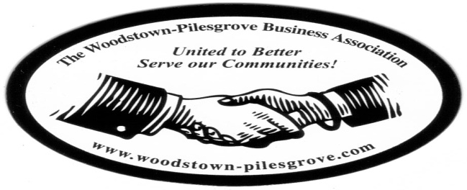

Woodstown-Pilesgrove Business Association
General Membership Meeting Minutes
Wednesday, July 8, 2015
Friends Village

Mission Statement: To Promote and Support our Local Businesses through
Networking, Shared Success and Training Opportunities

Facilitated By:

Peggy Scheule

Treasurer’s Report:

Beg Balance: 9517.00
Income: 975.00
Expenses: 1610.00
End Balance: 8882.00
Golf Balance: 9585.00

Karen Sparks motioned to accept the Treasurer’s Report, Kevin Gibala seconded

President’s Report:

Peggy praised Anne Elder for her dedication to making sure our July 4th was a huge success! She also thanked Andy for his help and support for the 5K Run.
The 5K Run netted a profit of $3114.20.

Peggy shared that although we did have an OT Meeting it was unofficial because we didn’t have enough members in attendance to qualify for a quorum.

Our “On The Road” will resume in September with Memorial Hospital of Salem County at their satellite location in Woodstown. Ryan Jensen the CEO will host this event. Doug Painter will do his presentation in October.

Salem County Chambers invited us to use their table at the Salem County Fair (we are not having a table this year), John Gasparon will bring our brochures to be handed out at the Fair.

VP Report:

Kevin reported that we have 3 new members .

Committee Reports:

Website Committee: Lori Petronglo – Kevin Gibala

Lori went over the new templet that Charlie Bell is working on for our upgraded website. She explained that in doing this we will have more flexibility when changing and adding links. Anne will send the pictures from the golf tournament and the July 4th Fireworks so we can upload them onto our website. Lori also asked that anyone who received an email requesting that they accept the google invitation to join the WPBA group accept it so we can start using this as a means to sending group emails.

Ambassador Committee: Paul Horvath

Paul was not available for comment

Government Committee: Joe Crevino

Joe was not available for an update
Activities/Programs: Hue Grant

Hue asked Doug Painter if he wouldn’t mind changing his presentation to October so that the Memorial Hospital of Salem County could sponsor our “On The Road” in September. He graciously agreed.

Parade:

Astro sign, at the last minute, kindly made the sign carried in the parade. Anne Elder used her golf cart in the parade to display the posters with the names of the Silver Sponsors of the Golf Tournament, she was also able to get a local rock band to play at the July 4th Fireworks for a couple of hours before the fireworks started.

Promotion/Marketing: Anne Elder

Fireworks:

Anne thanked everyone who played a part in helping to make the Fireworks such a success. She especially thanked Andy Ware, Aaron Crispin, Doug Painter, the police dept., fire dept., boy scouts, Woodstown Boro and many more. Peggy thanked Anne and Keith Elder for their commitment to seeing that this event happened on behalf of the WPBA. Peggy also said that we need to get the word out that the Fireworks were funded by the WPBA; some people think it was funded by the government.

Presenter:

The Red Cross did not show up so there was no presenter for this meeting.

Topics for Discussion:

“Can I ask your opinion?”

This discussion was met with ideas on how to get the SCC and the Salem Tourism to promote the fireworks next year. Other discussions included how to attract new members and possibly supporting a local charity with some of the profit from the fireworks next year.

Shout Outs:

Anne thanked Astro Signs for getting the last minute banner ready for the parade.

Peggy thanked Anne and Keith Elder for using their golf cart in the parade

Peggy thanked Christy Scarpa for coming from Vineland to walk in the parade.

Next General Membership Meeting will be on Wednesday,
September 9, 2015 -Memorial Hospital of Salem County - Woodstown, 7:45

