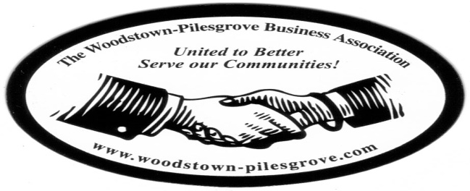

Woodstown-Pilesgrove Business Association
General Membership Meeting Agenda
Wednesday – April 8, 2015
First National Bank of Elmer

Mission Statement: To Promote and Support our Local Businesses through
Networking, Shared Success and Training Opportunities

Facilitated by: Peggy Scheule

Roll Call : What does Spring mean to you?

Treasurer’s Report
- General Account:
Beg Balance_______________
Income___________________
Expenses________________
End Balance______________
- Golf Outing Account: _____________

President’s Report
- Motion/ Approval of General Membership minutes from February & March
- Update from April Officers and Trustees Meeting

Vice-President’s Report
- “Outstanding Business of the Year”

Committee Reports:

Website Committee – Lori Petronglo & Kevin Gibala

Ambassador Committee – Paul Horvath

Government Relations Committee – Joe Crevino

Activities/Programs – Hue Grant & Chris Williams
Annual program assignments

Promotion/Marketing Anne Elder

Fundraising – Anne Elder
- 2015 Golf Outing Update

Fireworks Committee – Keith Elder

Program: Young Life of Salem County
- Pastor Jim Peterson, Asbury United Methodist church

Table Topic – How does the Weather affect your Business?

Member Shoutouts

Other Topics for Discussion…

Upcoming Dates, Events & Mixers to look for:
- Golf Outing – 5/22/15
- 4th of July Parade
- 4th of July Fireworks

Adjourn Meeting and Networking

Next General Membership Meeting - Wednesday, May 13th, 2015
Friends Village – Breakfast – 7:30 AM – Meeting 7:45

